**Covid 19 Cases Analysis**

**Project Description:**

**Phase 4: Development Part 2**

In the fourth phase of the "Covid 19 Cases Analysis" project, we will continue building upon the foundation established in the earlier phases. We've already collected and presented covid 19 cases data in Phase 1, performed exploratory data analysis in Phase 2, and in Phase 3, we build the models covid 19 cases development with the technologies. Phase 4 will encompass with the development in covid 19 cases analysis using these technologies called AI, ADS, CAD, IOT and DAC

**Artificial Intelligence (AI):**

Artificial Intelligence (AI) also started to play a role in the fight against it. In this section, we will cover several areas regarding AI and DL applications which are helping against COVID-19. The authors presented a detailed comparative analysis of AI-, ML-, and DL-based algorithms used to forecast and identify the epidemic and diagnose the consequences of COVID-19.The authors proposed a compound model for face mask detection. The proposed technique is a combination of both deep neural and traditional ML algorithms. In the first part of the DL algorithm, ResNet50 was used for high-level feature extraction. While in the second part, traditional ML algorithms named support vector machine, ensemble algorithms, and decision trees were used to detect face masks. Three different datasets were used in this research for the training and testing of the model. One dataset was for training while the other two datasets were used for the purpose of testing. The proposed technique achieved an average of 99.5% accuracy on all three datasets. The research offers a thorough evaluation of AI and ML as useful methods for tracking contacts, making predictions and forecasting. The authors discussed a thorough analysis of the current and promising use of AI and big data analytics (BDA) to manage the outbreak based on COVID-19 life cycle stages, such as detection, spread, management, and recovery. The authors also discussed the difficulties that BI in BDA in combat must face.

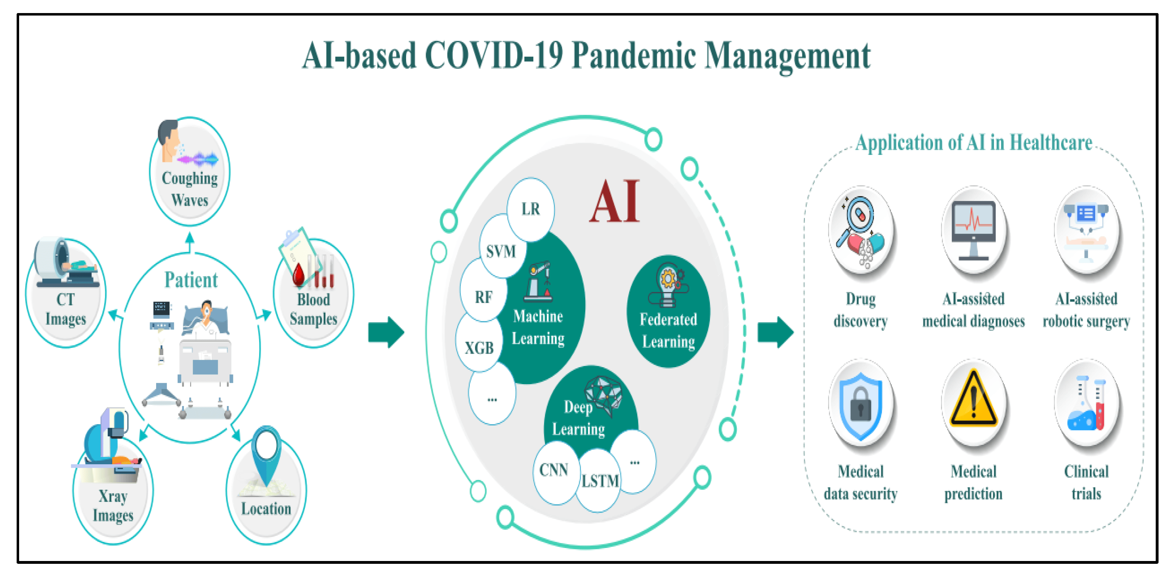

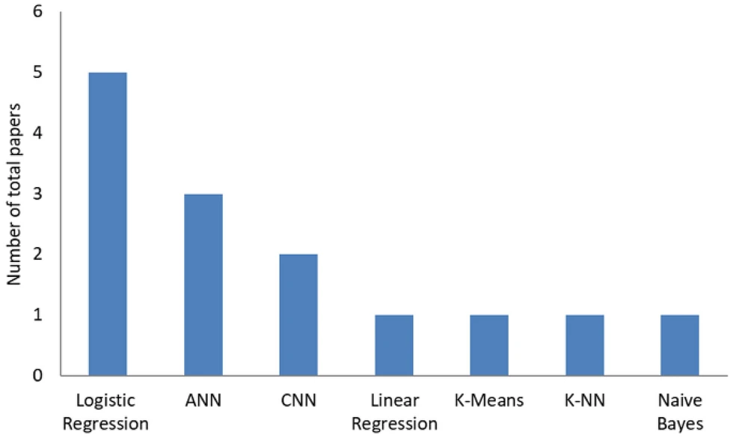

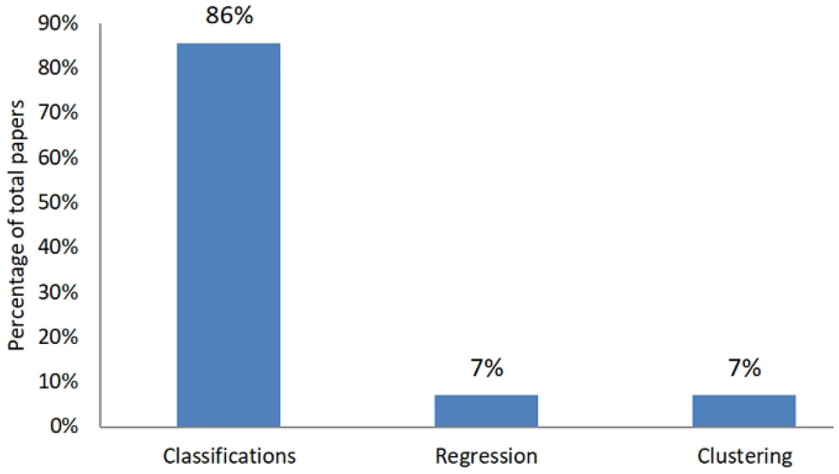

**Advanced Data Science (ADS):**

Data science, defined broadly, will play a central role in the global response to the COVID-19 pandemic. This paper facilitates the rapid engagement of data science and AI researchers with the breadth of the ongoing research work. In particular, we identify the major challenges involved, promising directions for further work, and important community resources. Given the interdisciplinary nature of the challenge, this review will help data scientists form collaborations across disciplines. We also elaborate the benefits of data science to strategists and policymakers and guide them in coming to grips with the challenges, opportunities, and pitfalls involved in using data science to combat the COVID-19 pandemic. COVID-19, an infectious disease caused by the SARS-CoV-2 virus, was declared a pandemic by the World Health Organisation (WHO) in March 2020. By mid-August 2020, more than 21 million people have tested positive worldwide. Infections have been growing rapidly and tremendous efforts are being made to fight the disease. In this paper, we attempt to systematise the various COVID-19 research activities leveraging data science, where we define data science broadly to encompass the various methods and tools-including those from artificial intelligence (AI), machine learning (ML), statistics, modelling, simulation, and data visualization-that can be used to store, process, and extract insights from data. In addition to reviewing the rapidly growing body of recent research, we survey public datasets and repositories that can be used for further work to track COVID-19 spread and mitigation strategies. As part of this, we present a bibliometric analysis of the papers produced in this short span of time. Finally, building on these insights, we highlight common challenges and pitfalls observed across the surveyed works. We also created a live resource repository at https://github.com/Data-Science-and-COVID-19/Leveraging-Data-Science-To-Combat-COVID-19-A-Comprehensive-Review that we intend to keep updated with the latest resources including new papers and datasets.

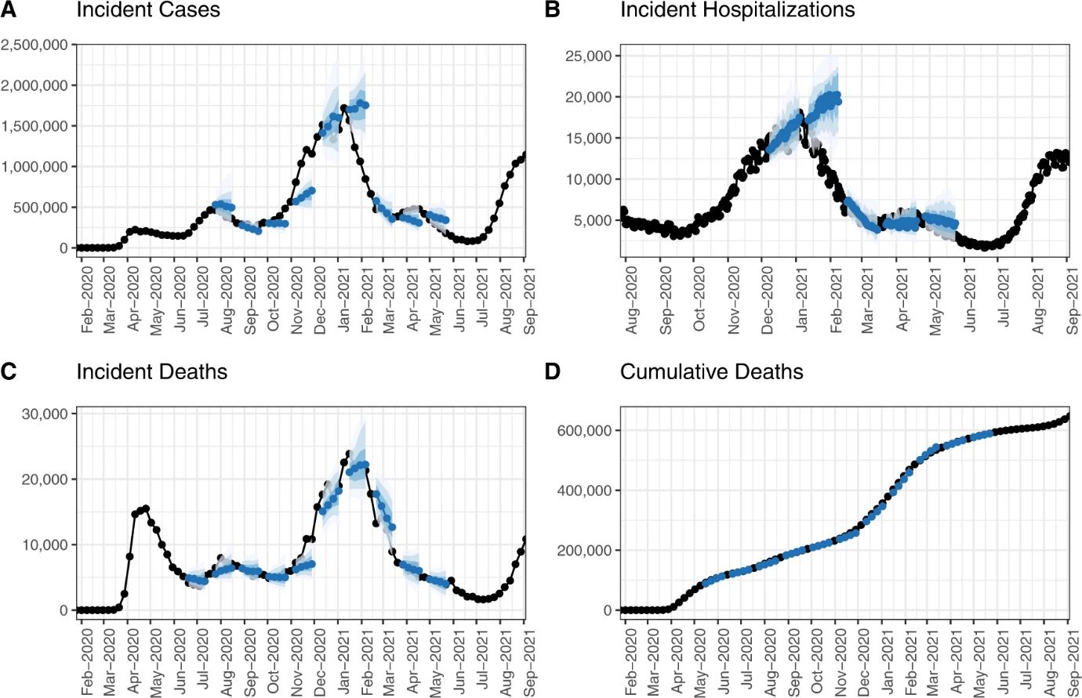

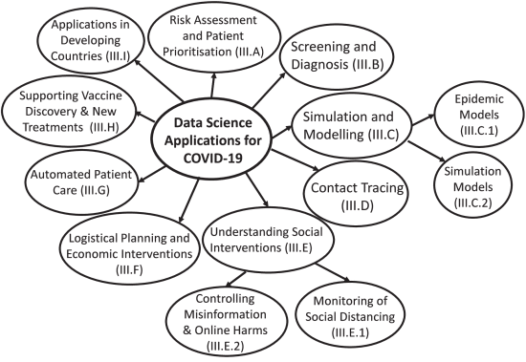

**Data Analytics and Cloud (DAC):**

In this section, we present how data analytics can be used in predicting the new daily cases of COVID-19. Instead of using the traditional approaches, which either focus on historical data or assume a normal distribution for the number of daily cases, we use a data analytics approach. In particular, this approach has the ability to consider a massive amount of data, including historical data of daily cases besides other external factors. The proposed methodology includes a nonlinear autoregressive exogenous input (NARX) neural network-based algorithm. The main steps of this algorithm are presented as follows:

Step1:

Collecting the data. The data have been collected from online websites, including “Worldometers”, “Our World in Data”, “World Bank Open Data”, and the official website of the World Health Organization (WHO). Besides, human development reports have been used to pick other kind of information, like median age and education index. The scope of this study includes collecting data for about 189 countries/territories by focusing on two types of data: main data and other external factors. The main data include considering the number of confirmed coronavirus disease cases/day, the number of deaths due to coronavirus disease/day, and the total number of confirmed cases. The external factors, on the other hand, include considering the factors that affect the spread of coronavirus disease. Note that the data have been collected for about 224 days, from 31 December 2019 until 10 August 2020. This leads naturally to set the size of data at 224.

Step 2:

Preprocessing the data. While collecting the data, it was observed that data were not always available for the whole 189 countries/territories. To alleviate this situation, a refinement was performed by ruling out any countries/territories that suffer from data unavailability. This results in cancelling around 39 countries/territories, so that only 150 countries/territories have been considered. Our preliminary goal is to predict the new cases for all 150 countries/territories. However, this is not reasonable for two reasons. Firstly, it is not possible to present all the results in a single study due to page limitation. Secondly, it is computationally expensive to run this algorithm for 150 countries/territories. For the above reasons, we have limited our scope to considering the most affected countries in each continent. By doing so, the top five affected countries/territories have been considered from each continent.

Step 3:

Identifying the input sets. These sets contain historical data of some information alongside the external factors.

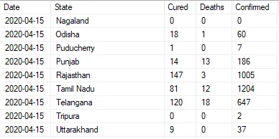

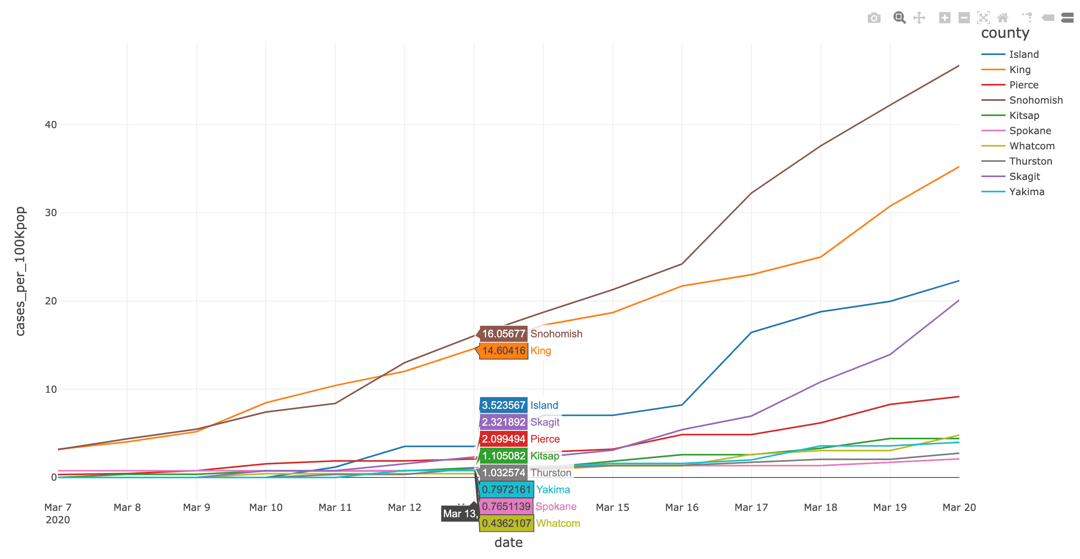

**Internet Of Things (IOT):**

The Internet of Things (IoT) has gained convincing research ground as a new research topic in a wide variety of academic and industrial disciplines, especially in healthcare. The IoT revolution is reshaping modern healthcare systems by incorporating technological, economic, and social prospects. It is evolving healthcare systems from conventional to more personalized healthcare systems through which patients can be diagnosed, treated, and monitored more easily. The current global challenge of the pandemic caused by the novel severe respiratory syndrome coronavirus 2 presents the greatest global public health crisis since the pandemic influenza outbreak of 1918. At

the time this paper was written, the number of diagnosed COVID-19 cases around the world had reached more than 31 million. Since the pandemic started, there has been a rapid effort in different research communities to exploit a wide variety of technologies to combat this worldwide threat, and IoT technology is one of the pioneers in this area. In the context of COVID-19, IoT-enabled/linked devices/applications are utilized to lower the possible spread of COVID-19 to others by early diagnosis, monitoring patients, and practicing defined protocols after patient recovery. This paper surveys the role of IoT-based technologies in COVID-19 and reviews the state-of-the-art architectures, platforms, applications, and industrial IoT-based solutions combating COVID-19 in three main phases, including early diagnosis, quarantine time, and after recovery.

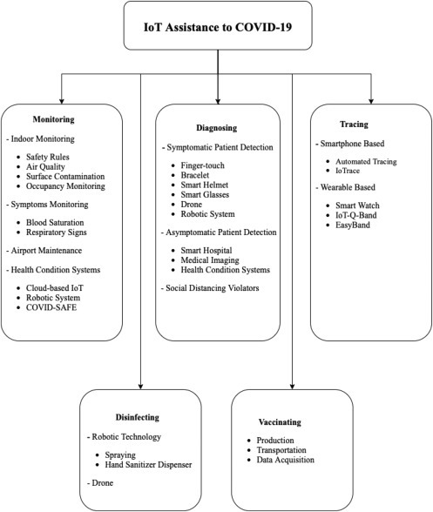

**Computer-Aided Design:**

Analysing COVID-19 cases using Computer-Aided Design (CAD) technology is a non-conventional approach, primarily known for design and drafting purposes. However, CAD can find a unique role in the pandemic's response in certain aspects. CAD can be employed to create spatial representations of COVID-19 case data, visualizing geographical distributions. It is valuable for designing layouts of healthcare facilities, testing centers, and quarantine spaces, optimizing space utilization while adhering to safety guidelines. CAD's 3D modeling capabilities allow for unique data visualization, offering insights into trends and patterns not easily discernible through traditional charts.

Furthermore, it can simulate the spread of the virus within confined spaces, assisting in ventilation assessments and crowd management. Additionally, CAD can aid in the design and prototyping of medical equipment and be used for educational purposes, explaining complex concepts about the virus. Though unconventional, CAD technology can complement COVID-19 data analysis, primarily focusing on spatial and design aspects for preparedness and response efforts. CAD is traditionally associated with design and drafting.

However, in the context of pandemic response, CAD can play a limited yet innovative role. CAD software can be employed to create 2D or 3D spatial representations of COVID-19 case data, offering a unique perspective on the geographic spread of the virus. This can aid in visualizing and planning layouts for healthcare facilities, testing centers, and quarantine spaces, ensuring efficient use of space while adhering to safety guidelines. Additionally, CAD's 3D modeling capabilities can be utilized to simulate the spread of the virus within specific environments, helping assess ventilation systems, crowd management, and the effectiveness of physical barriers. While not a primary tool for COVID-19 data analysis, CAD can be a valuable complement for tasks related to spatial design and visualization, contributing to preparedness and response efforts during the pandemic.

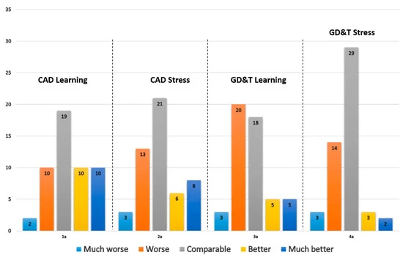

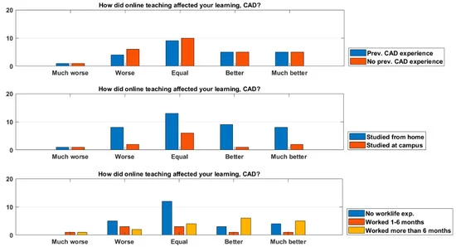

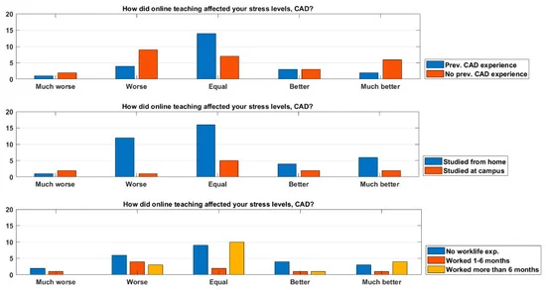

By integrating these technologies, you can establish a comprehensive and data-driven approach to COVID-19 analysis. Real-time IoT data can feed into AI and data analytics systems, which can be hosted in the cloud for scalability and accessibility. The insights generated by AI and data science can inform decision-making and public health measures. Meanwhile, CAD technology can contribute to facility planning and spatial analysis. This multi-faceted approach allows for a more effective response to the pandemic by combining the strengths of each technology.

Submit by:

K. Viswa teja

au720921243028